Electric Motor Temperature Prediction
Project Documentation format
1. Introduction
• Project Title: Electric Motor Temperature Prediction using AIML
• Team Members:
- Mohana Pravallika Kolla – Frontend Development (HTML, CSS, Templates)
- Sareddy Vijay Kumar Reddy – Backend Development (Flask – app.py)
- Maturi Anvitha – Machine Learning Model Development (Jupyter Notebook)
- Kiran Siva Pallagorla – Dataset Management & Deployment

2. Project Overview
• Purpose:
The purpose of EMTP (Electric Motor Temperature Prediction) is to predict the operating temperature of an electric motor using Machine Learning algorithms based on various input parameters such as:
- Voltage
- Current
- Speed
- Torque
- Ambient Temperature
- Vibration
- Load Percentage
The system helps industries to:
- Detect overheating conditions
- Prevent motor failure
- Reduce maintenance costs
- Improve industrial safety

3. Architecture
User (Browser)
↓
Frontend (templates/index.html)
↓
Flask Backend (app.py)
↓
Trained ML Model (Notebook)
↓
Prediction Result
↓
Displayed to User
🖥 Frontend
- Built using HTML templates (templates/index.html)
- Styled with CSS (static folder)
- Accepts motor input parameters
- Displays predicted temperature dynamically
- Shows overheating alert if temperature exceeds threshold

⚙ Backend (Flask)
- Developed using Python Flask framework
- Handles prediction requests
- Loads trained ML model (.pkl file)
- Performs input validation
- Returns prediction results to frontend

4. Setup Instructions and Installations:
• Python 3.x
• Flask
• Jupyter Notebook
• Pandas
• NumPy
• Scikit-learn

5. Folder Structure
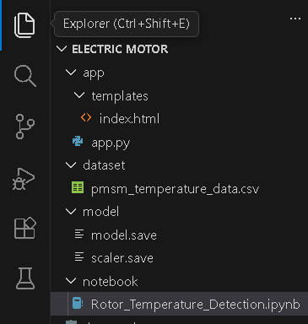
Application
- Train the model in Jupyter Notebook.
- Generate model.pkl.
- Place model file in project root.
- Run Flask backend:
python app.py
http://127.0.0.1:5000/
7. API Documentation
• Predict Temperature
Endpoint: /predict
Method: POST
Input Parameters:
- voltage
- current
- speed
- torque
- ambient
- vibration
- load
Response:
- Predicted Motor Temperature
- Overheat Alert (if > 80°C)

8. Authentication
- User Registration
- User Login
- Secure Password Storage
- Session-based Authentication
- Admin Access Control

9. User Interface
• Provide screenshots or GIFs showcasing different UI features.
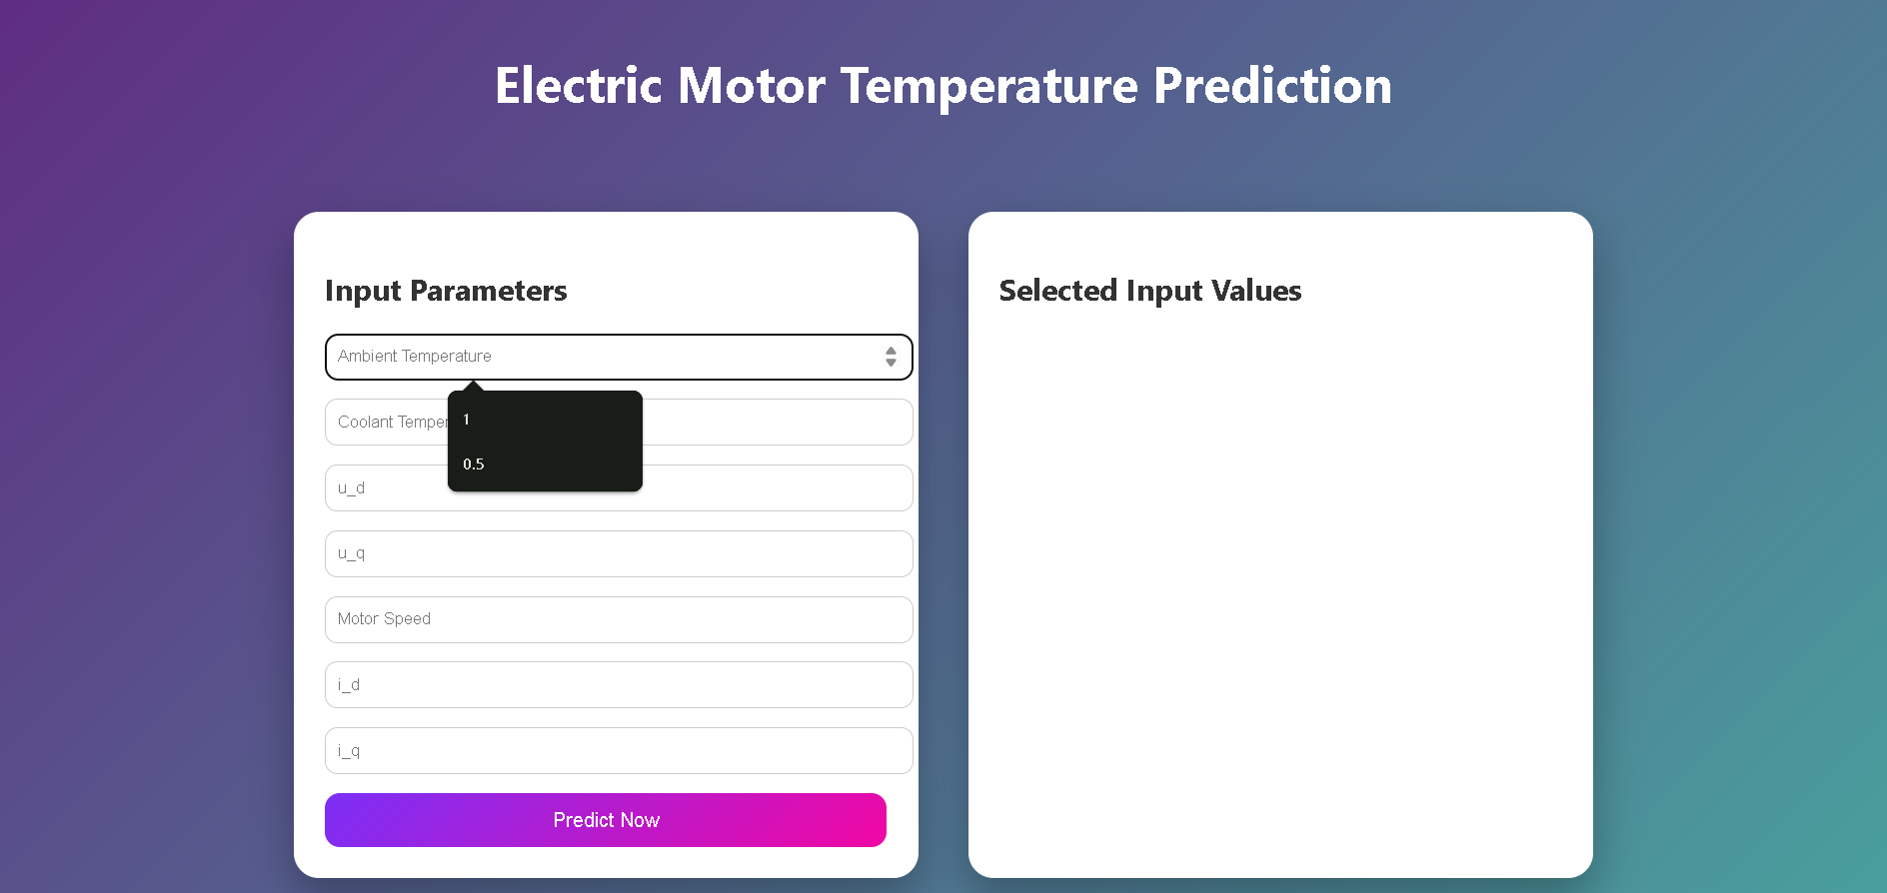
After prediction
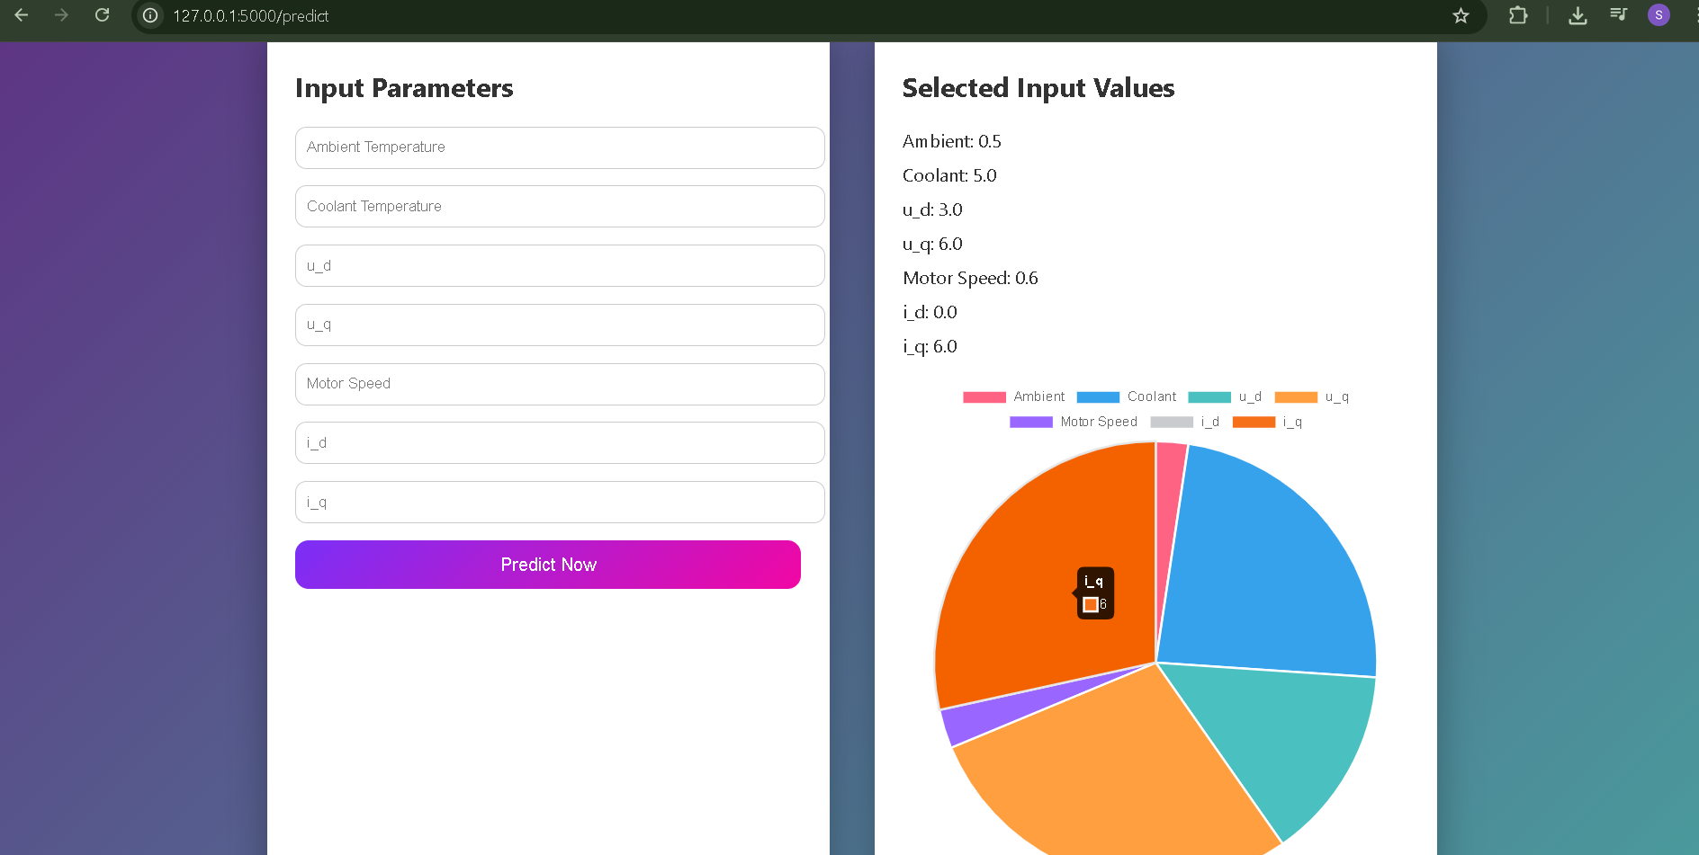
10. Testing
- Unit Testing using Jest
- API Testing using Postman
- Model Accuracy Testing (R² = 0.96)
- Performance Testing (<2 sec response time)

11. Screenshots or Demo
https://drive.google.com/file/d/12pdCAqTBL3NUu_uJU43DVayOhc13_B8/view?usp=sharing
12. Known Issues
- Session expires after browser close
- Requires proper secret key configuration
- If database connection fails, login may not work

13. Future Enhancements
- JWT-based token authentication
- Google OAuth login
- Two-Factor Authentication (OTP)
- Role-based access control (RBAC)
- Password reset via email

